PF-LAB TASK:01

BY

TOUQEER ALI (NUML-S25-18448)



SUBJECT (Programming Fundamental)

SUBMITTED TO (MARYIM IMTIAZ)

NATIONAL UNIVERSITY OF MODERN LANGUAGES ISLAMABAD

**QUESTION NO :1**

**PRINT (SEPF-121) (Programming Fundamental)**

**Code:**

#include<iostream>

using namespace std;

int main()

{

cout << "SEPF-121\n Programming Fundamentals";

return 0;

}

**Output:**

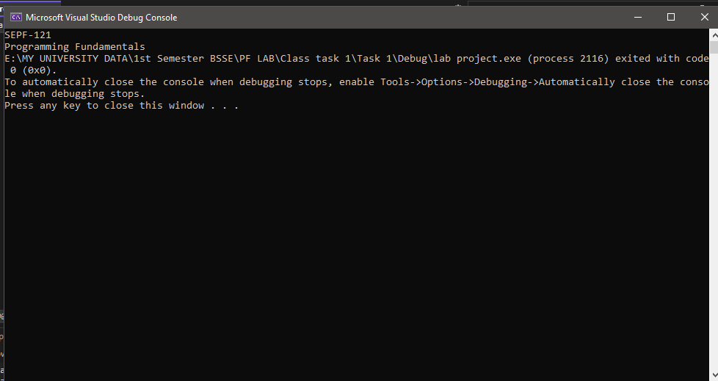

**QUESTION NO :2**

**PRINT STARS IN A CONE SHAPE**

**Code:**

#include<iostream>

using namespace std;

int main()

{

cout << "******\n*****\n****\n***\n**\n*";

return 0;

}

**Output:**

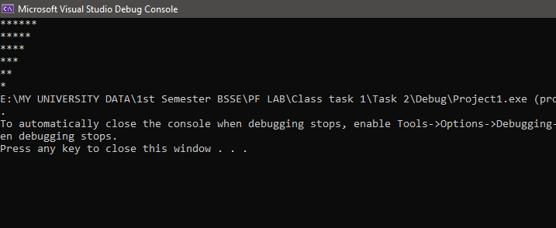

**QUESTION NO :3**

**PRINT ALL ESCAPE CHARACTERS IN C++**

**Code:**

#include <iostream>

using namespace std;

int main() {

    cout << "My name is \"TOUQEER ALI\" \n I take the admission in \'NUML UNIVERSITY ISLAMABAD\' \n My interest is in software\tengineering\n I love coding in C++\\Python\\JavaScript\n";

    return 0;

}

**Output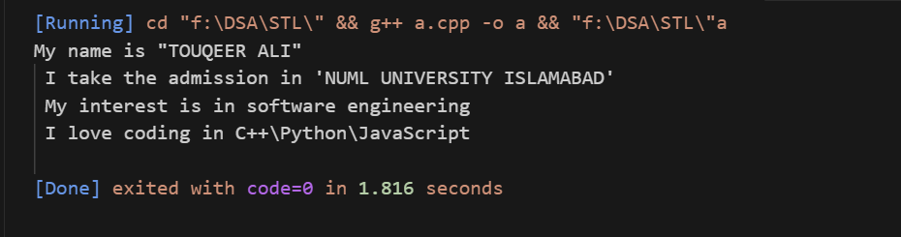:**

Programming Fundamental Lab Task

BY

Touqeer Ali (NUML-S25-18448)



SUBJECT (Programming Fundamental)

SUBMITTED TO (Maryam Imtiaz)

NATIONAL UNIVERSITY OF MODERN LANGUAGES ISLAMABAD

**Task 1:`**

Write a program to assign values to different variables at the time of declaration. Print the assigned values on the computer screen.

#include<iostream>

#include<vector>

using  namespace std;

int main(){

int num1 = 34 ;

float num2 = 12.34;

char ch = '@';

cout<<"The Integer Number is "<<num1<<endl;

cout<<"The Decimal Number  is "<<num2<<endl;

cout<<"The Character is "<<ch<<endl;

    return 0 ;

}

**Output:**

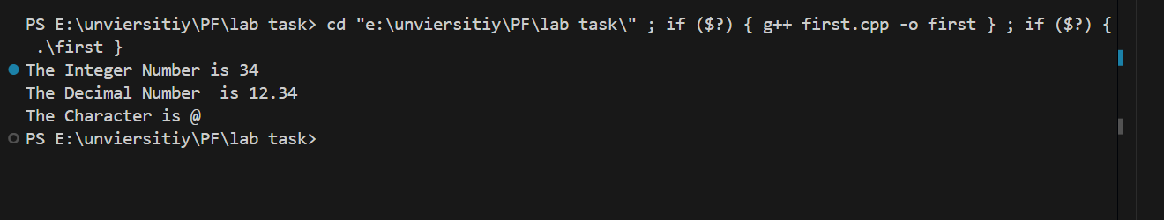

**Task 2:**

Write a program to perform arithmetic operations by using all arithmetic operators. Also print results on the screen.

#include<iostream>

using  namespace std;

int main(){

int num1 , num2 ;

cout<<"Enter the first Number \n ";

cin>>num1;

cout<<"Enter the second Number \n ";

cin>>num2;

cout<<"The Sum of the " <<num1<<" and "<<num2<<"  is "<<num1+num2<<endl;

cout<<"The difference  of the " <<num1<<" and "<<num2<<"  is "<<num1-num2<<endl;

cout<<"The product of the " <<num1<<" and "<<num2<<"  is "<<num1*num2<<endl;

cout<<"The division of the " <<num1<<" and "<<num2<<"  is "<<num1/num2<<endl;

­­cout<<"The Reminder  of the " <<num1<<" and "<<num2<<"  is "<<num1%num2<<endl;

    return 0 ;

}

**Output:**

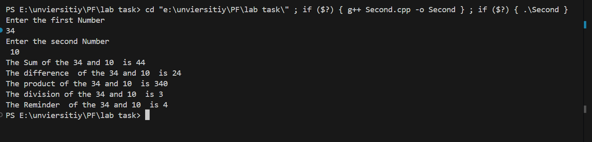

**Task 3:**

Write a program to assign two variables by assignment statement. Interchange the values and print the result on the screen.

#include<iostream>

using  namespace std;

int main(){

int num1 = 34 , num2 = 56 , temp = 0 ;

temp = num2;

num2 = num1;

num1 = temp ;

cout<<num1<<endl;

cout<<num2<<endl;

    return 0 ;

}

**Output:**

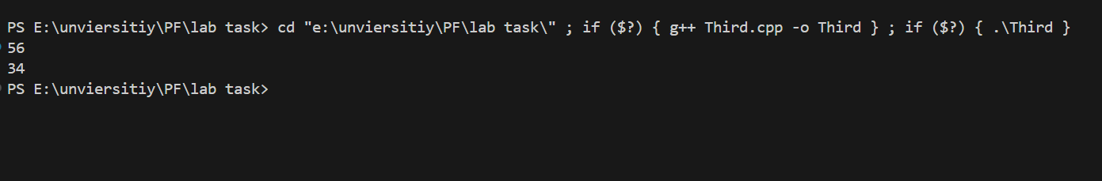

**Task 4:**

Write a program to assign two variables by assignment statement. Interchange the values and print the result on the screen (without using third variable).

#include <iostream>

using namespace std;

int main()

{

    int num1 = 3, num2 = 7;

    num1 = num1 + num2; // 3+7 = 10

    num2 = num1 - num2; // 10 -7 = 3

    num1 = num1 - num2; // 10 -3 = 7

    cout << num1 << endl;

    cout << num2 << endl;

    return 0;

}

**Output:**

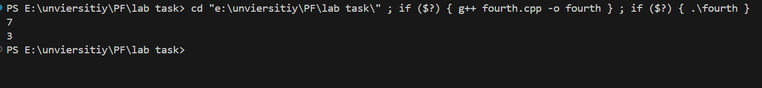

**Task 5:**

Write a program that calculates the area and circumference of the circle with the output formatted in the following way:

Output:

Enter the radius of the circle = radius

The area of circle is = area

The circumference of circle is = circumference

#include <iostream>

#include <cmath>

using namespace std;

int main()

{

    int Radius = 0;

    const int pi = 3.1415;

    cout << "Enter the Value of the Radius" << endl;

    cin >> Radius;

    cout << "The Area of the Circle is " << pi * pow(Radius, 2) << endl;

    cout << "The Circumference of The Circle is " << 2 * pi * Radius << endl;

    return 0;

}

**Output:**

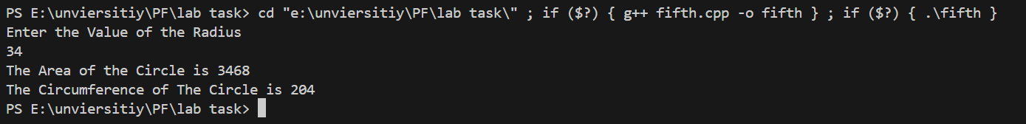

Programming Fundamental Lab Task 03

BY

Touqeer Ali (NUML-S25-18448)



SUBJECT (Programming Fundamental)

SUBMITTED TO (Maryam Imtiaz)

NATIONAL UNIVERSITY OF MODERN LANGUAGES ISLAMABAD

**Question No 01:**

**Write a program to find whether the given number is even or odd. The output of the program should be like:**

**Enter the number: 70**

**The number is even**

#include <iostream>

using namespace std;

int main() {

    int num;

    cout << "Enter the number : ";

    cin >> num;

    if (num % 2 == 0) {

        cout << "The number is even" << endl;

    } else {

        cout << "The number is odd" << endl;

    }

    return 0;

}

**Output:**

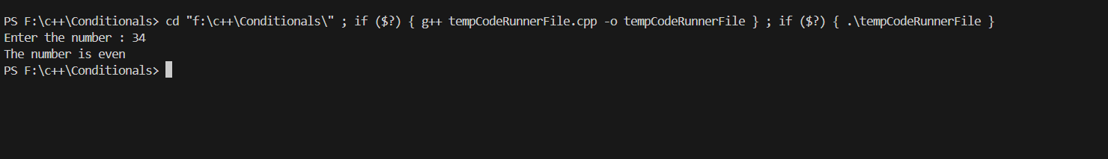

**Question No 2:**

Write a program in C++ to input marks obtained by a student in five subjects. The total marks of each subject is 100. Find out the grade of the student by using the if-else nested structure. The grade is:

• If percentage is equal to or greater than 80, grade is A

• If percentage is equal to or greater than 70 and less than 80, grade is B

• If percentage is equal to or greater than 60 and less than 70, grade is C

• If percentage is equal to or greater than 50 and less than 60, grade is D

• If percentage is less than 50, grade is “F”.

#include <iostream>

using namespace std;

int main()

{

    float s1, s2, s3, s4, s5;

    cout << "Enter the marks of five subjects max num is (100) \n ";

    cin >> s1 >> s2 >> s3 >> s4 >> s5;

    if (s1 > 100 || s1 < 0 || s3 > 100 || s3 < 0 || s3 > 100 || s3 < 0 || s4 > 100 || s4 < 0 || s5 > 100 || s5 < 0)

    {

        cout << " please enter the number between 0 to 100  \n ";

        cout << "Enter the marks of five subjects max num is (100) \n ";

        cin >> s1 >> s2 >> s3 >> s4 >> s5;

    }

    float Total_Marks = s1 + s2 + s3 + s4 + s5;

    float percentage = (Total_Marks / 500) * 100;

    char grade;

    if (percentage >= 80)

    {

        grade = 'A';

    }

    else if (percentage >= 70 && percentage < 80)

    {

        grade = 'B';

    }

    else if (percentage >= 60 && percentage < 70)

    {

        grade = 'C';

    }

    else if (percentage >= 50 && percentage < 60)

    {

        grade = 'D';

    }

    else

    {

        grade = 'F';

    }

    cout << grade;

    return 0;

}

**Output:**

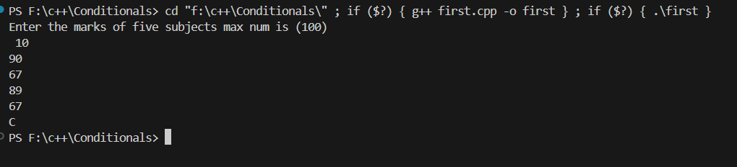

**Question No 3:**

Write a program that takes an integer input from the user and decides whether it’s positive, negative or zero?

#include <iostream>

using namespace std;

int main()

{

    int num;

    cout << "Enter the number \n";

    cin >> num;

    if (num > 0)

    {

        cout << num << " is positive ";

    }

    else if (num < 0)

    {

        cout << num << " is negative ";

    }

    else

    {

        cout << num << " is zero ";

    }

    return 0;

}

**Output:**

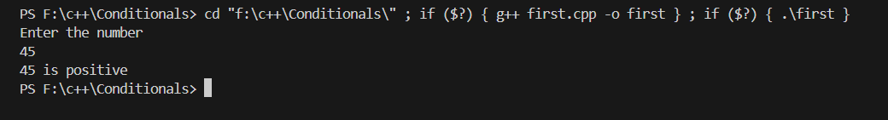

**Question No 04:**

.Write a C++ program (use if-else statement) to compute the telephone bill for the city consumers. The bill computed according to the number of calls.

• If numbers of calls are less than and equal to 100, then the rate per call is rs.0.80 and the meter charges is Rs. 250.

• If numbers of calls are greater than 100 but less than and equal to 250, then the rate per call is computed is Rs. 1.00 and the meter charges are minimum Rs.350.

• But if the number of calls is greater than 250, then the rate per number of call is Rs.1.25 and meter charges are minimum Rs.500.

Bill = meter_charges + (number_calls * rate_per_call)

#include <iostream>

using namespace std;

int main()

{

    float Bill, meter_charges, number_calls, rate_per_cell;

    cout << "Enter the number of the calls \n";

    cin >> number_calls;

    if (number_calls <= 100)

    {

        rate_per_cell = 0.80;

        meter_charges = 250;

    }

    else if (number_calls > 100 && number_calls < 250)

    {

        rate_per_cell = 1.00;

        meter_charges = 350;

    }

    else

    {

        rate_per_cell = 1.25;

        meter_charges = 500;

    }

    Bill = meter_charges + (number_calls * rate_per_cell);

    cout << "the number of the calls is " << number_calls << " and the meter charges is " << meter_charges << "and the rate per calls is " << rate_per_cell << " and the bill is " << Bill;

    return 0;

}

**Output:**

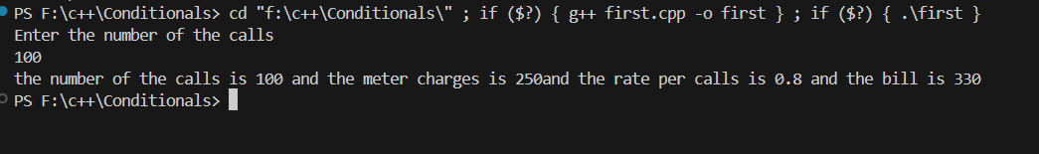

**The End**

Programming Fundamental Lab TASK/ASSIGNMENT: 04

BY

Touqeer Ali (NUML-S25-18448)



SUBJECT (Programming Fundamental)

SUBMITTED TO (Maryam Imtiaz)

DATE: 12-03-2025

NATIONAL UNIVERSITY OF MODERN LANGUAGES ISLAMABAD

**Question No 01:**

Write a program that takes as input arithmetic operators (+, -, *, /) and two integer inputs from the users. Based on the operator it performs the respective operation. Accomplish this using switch statement.

#include <iostream>

#include <vector>

using namespace std;

int main()

{

    int num1, num2;

    char ch;

    cout << "Enter the First number \n";

    cin >> num1;

    cout << "Enter the second number \n ";

    cin >> num2;

    cout << "Enter the character in Which you operation performed \n ";

    cin >> ch;

    switch (ch)

    {

    case '+':

        cout << " The sum of the " << num1 << " and " << num2 << " is " << num1 + num2;

        break;

    case '-':

        cout << " The difference  of the " << num1 << " and " << num2 << " is " << num1 - num2;

        break;

    case '*':

        cout << " The product of the " << num1 << " and " << num2 << " is " << num1 * num2;

        break;

    case '/':

        cout << " The division  of the " << num1 << " and " << num2 << " is " << num1 / num2;

        break;

    default:

        cout << "You do no Entered the these arithmetic operators (+, -, *, /) \n";

        break;

    }

    return 0;

}

**Output:**

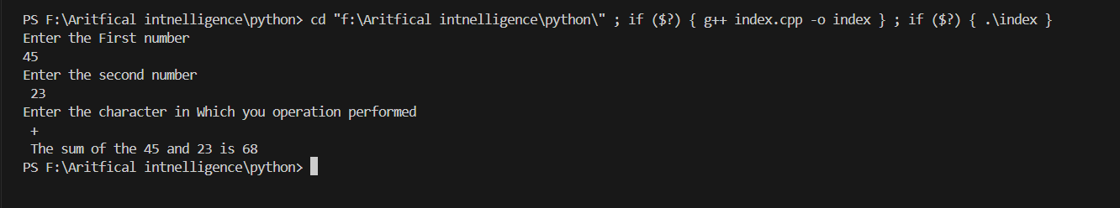

**The End.**

Programming Fundamental Lab TASK/ASSIGNMENT: 05

BY

Touqeer Ali (NUML-S25-18448)



SUBJECT (Programming Fundamental)

SUBMITTED TO (Maryam Imtiaz)

DATE: 12-03-2025

NATIONAL UNIVERSITY OF MODERN LANGUAGES ISLAMABAD

**Question No 01:**

Write a program to find the average of N numbers using loop. The output of the program should be like:

Enter the number = 5

Sum = 15

Average = 3

#include <iostream>

#include <vector>

using namespace std;

int main()

{

    int num;

    cout << "Enter the  number \n";

    cin >> num;

    int sum = 0;

    for (int i = 01; i <= num; i++)

    {

        sum += i;

    }

    cout << "Sum = " << sum << "\n";

    cout << "Average = " << sum / num;

    return 0;

}

**Output**

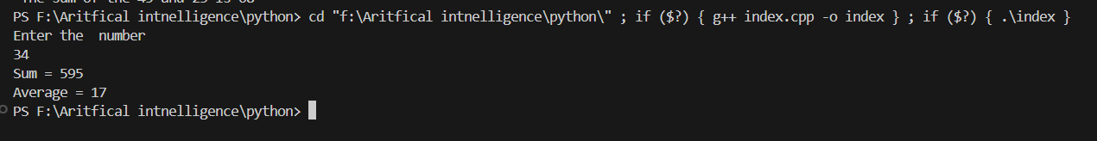

**Question No 02:**

Write a program using loop which displays alphabets from Z-A.

#include <iostream>

#include <vector>

using namespace std;

int main()

{

    for (char ch ='Z'; ch >='A' ; ch++)

    {

        cout<<ch<<"\t";

    }

    return 0;

}

**Output:**



**Question No 03:**

Implement a C++ program that allows users to convert temperatures from Celsius to Fahrenheit. Use a loop to continually prompt the user for temperature values to convert until they decide to exit the program.

#include <iostream>

#include <vector>

using namespace std;

int main()

{

    for (char permission = 'y'; permission != 'n';)

    {

        int Celsius, Fahrenheit;

        cout << "Enter the Temperature in Celsius \n ";

        cin >> Celsius;

        Fahrenheit = (Celsius * 1.8) + 32;

        cout << "The temperature in Fahrenheit is " << Fahrenheit;

        cout << "\n Enter the n to stop the program and enter other character to continue the program \n ";

        cin >> permission;

    }

    return 0;

}

**Output**

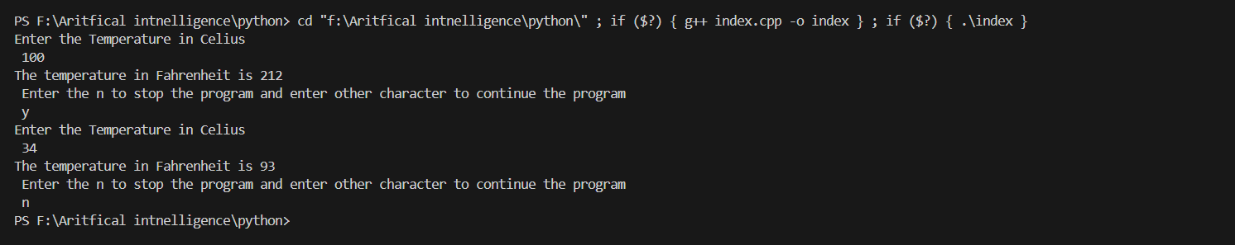

Programming Fundamental TASK/ASSIGNMENT: 06

BY

Touqeer Ali (NUML-S25-18448)



SUBJECT (Programming Fundamental)

SUBMITTED TO (Mam Maryam Imtiaz Malik)

DATE: 16-03-2025

NATIONAL UNIVERSITY OF MODERN LANGUAGES ISLAMABAD

**Question No 01:**

Create the equivalent of a four-function calculator. The program should request the user to enter a number, an operator, and another number. (Use floating point.) It should then carry out the specified arithmetical operation: adding, subtracting, multiplying, or dividing the two numbers. Use a switch statement to select the operation. Finally, display the result. When it finishes the calculation, the program should ask if the user wants to do another calculation. The response can be ‘y’ or ‘n’. Some sample interaction with the program might look like this:

Enter first number, operator, and second number: 2*5

Answer = 10

Do another (y/n)? y

Enter first number, operator, and second number: 12 + 100

Answer = 112

Do another (y/n)? n

#include <iostream>

using namespace std;

int main()

{

    double num1, num2, result;

    char op, choice = 'y';

    while (choice == 'y' || choice == 'Y')

    {

        cout << "Enter first number, operator, and second number: ";

        cin >> num1 >> op >> num2;

        switch (op)

        {

        case '+':

            result = num1 + num2;

            break;

        case '-':

            result = num1 - num2;

            break;

        case '*':

            result = num1 * num2;

            break;

        case '/':

            result = num1 / num2;

            break;

        default:

            cout << " Please use +, -, *, or /." << endl;

        }

        cout << "Answer = " << result << endl;

        cout << "Do another (y/n)? ";

        cin >> choice;

    }

    return 0;

}

Output:

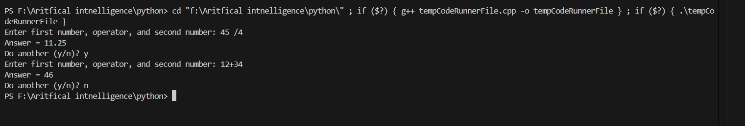

Question No 02:

#include <iostream>

using namespace std;

int main() {

    double income, expenses, deductions, taxable_income, tax;

    char choice = 'y';

    while (choice == 'y' || choice == 'Y') {

        cout << "Enter your income: ";

        cin >> income;

        cout << "Enter your expenses: ";

        cin >> expenses;

        cout << "Enter your tax deductions: ";

        cin >> deductions;

        taxable_income = income - expenses - deductions;

        if (taxable_income < 0) {

            cout << "No tax owed, as your taxable income is less than zero." << endl;

        } else {

            tax = taxable_income * 0.20;

            cout << "Amount owed is: $" << tax << endl;

        }

        cout << " calculate another tax refund? (y/n): ";

        cin >> choice;

    }

    return 0;

}

Output

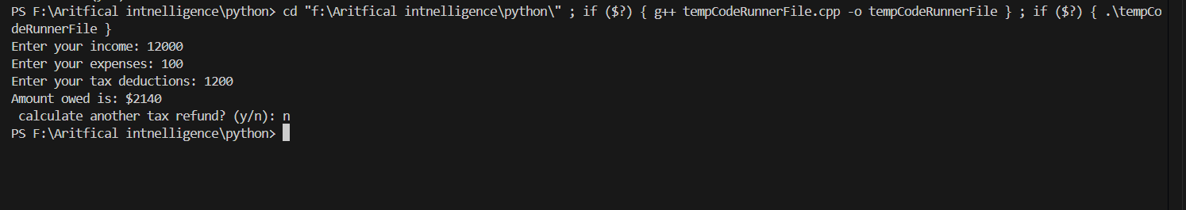

The End

Programming Fundamentals/Lab Task 07

BY

Touqeer Ali (NUML-S25-18448)



SUBJECT (PF)

SUBMITTED TO (Mam Maryam Imtiaz Malik)

DATE:21-03025

NATIONAL UNIVERSITY OF MODERN LANGUAGES ISLAMABAD

**Question No 01:**

Write a program to print the reverse of any number of digits.

#include <iostream>

using namespace std;

int main() {

    int number, reverse = 0, remainder;

    cout << "Enter a number: ";

    cin >> number;

    while (number != 0) {

        remainder = number % 10;

        reverse = reverse * 10 + remainder;

        number /= 10;

    }

    cout << "The reverse of the number is: " << reverse << endl;

    return 0;

}

**Solution**

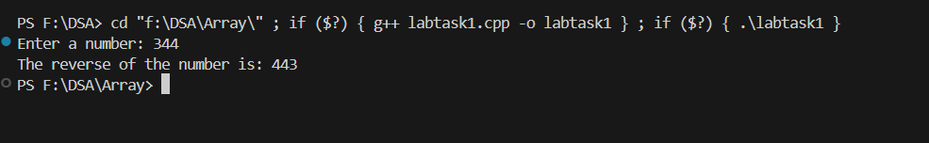

**Question No 02**

A bank's ATM allows users to withdraw money in multiples of 100. Write a C++ program that continuously asks the user to enter an amount to withdraw until they enter a valid multiple of 100.

#include <iostream>

using namespace std;

int main() {

    int amount;

    do {

        cout << "Enter the amount : ";

        cin >> amount;

        if (amount % 100 == 0) {

            cout << "You  entered THE valid amount: " << amount << endl;

        } else {

            cout << "Invalid amount. Please enter a multiple of 100." << endl;

        }

    } while (amount % 100 != 0);

    return 0;

}

**Output**

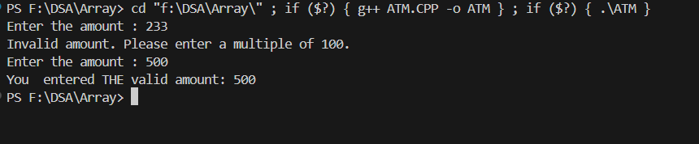

**Question No 03**

A library charges a fine for late book returns. Write a program that asks the user for the number of days a book is overdue and calculates the fine as follows: 1-5 days late: Rs 2 per day 6-10 days late: Rs 5 per day More than 10 days: Rs 10 per day More than 30 days: Membership is canceled. The program should continue asking for input until the user enters 0 to exit

#include <iostream>

using namespace std;

int main() {

    int days;

    int fine;

    while (true) {

        cout << "Enter the number of day (enter 0 to exit):      \n ";

        cin >> days;

        if (days == 0)   break;

        if (days >= 1 && days <= 5) {

            fine = days * 2;

            cout << "The fine for " << days << " day(s) overdue is Rs " << fine << ".\n";

        } else if (days >= 6 && days <= 10) {

            fine = days * 5;

            cout << "The fine for " << days << " day(s) overdue is Rs " << fine << ".\n";

        } else if (days > 10 && days <= 30) {

            fine = days * 10;

            cout << "The fine for " << days << " day(s) overdue is Rs " << fine << ".\n";

        } else if (days > 30) {

            cout << "Membership is canceled due to the book being overdue for more than 30 days.\n";

        }

    }

    return 0;

}

Solution

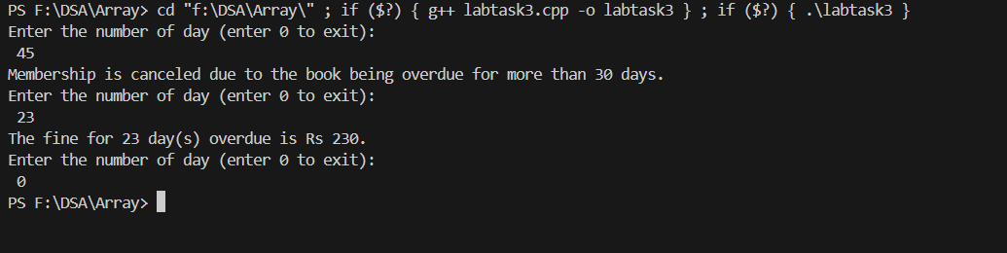

The End

Programming Fundamental /Lab Task 8

BY

Touqeer Ali (NUML-S25-18448)



SUBJECT (Programming Fundamental)

SUBMITTED TO (Mam Maryam Imtiaz)

DATE: 27-03-2025

NATIONAL UNIVERSITY OF MODERN LANGUAGES ISLAMABAD

**Question No 1:**

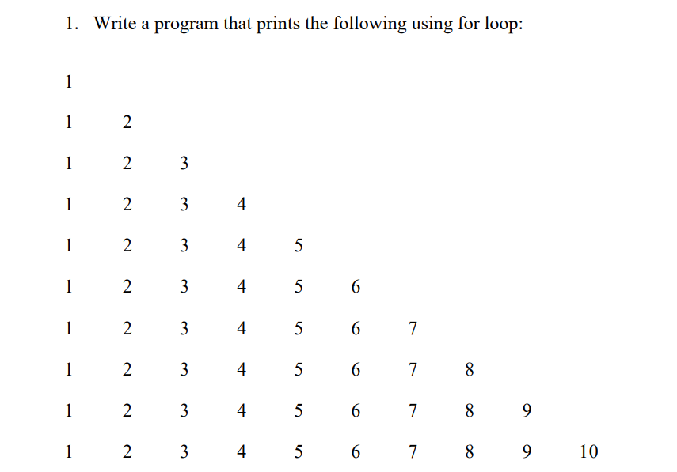

#include <iostream>

using namespace std;

int main()

{

    for (int i = 0; i <= 10; i++)

    {

        for (int j = 01; j <= i; j++)

        {

            cout << i << " ";

        }

        cout << endl;

    }

    return 0;

}

**Output**

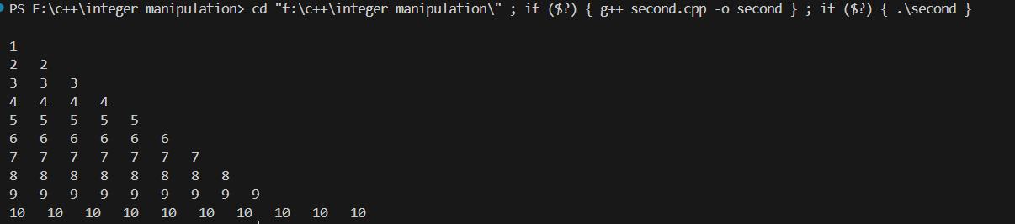

**Question No 02**

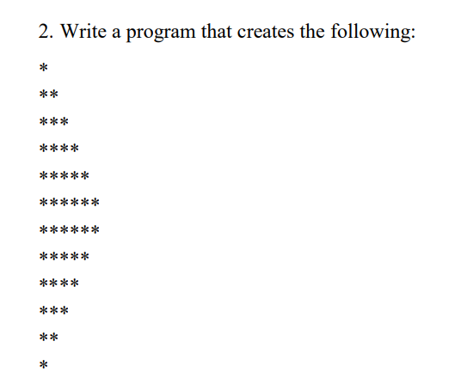

#include <iostream>

using namespace std;

int main()

{

    for (int i = 1; i <= 6; i++)

    {

        for (int j = 1; j <= i; j++)

        {

            cout << "*";

        }

        cout << endl;

    }

    for (int i = 6; i >= 1; i--)

    {

        for (int j = 1; j <= i; j++)

        {

            cout << "*";

        }

        cout << endl;

    }

    return 0;

}

**Output**

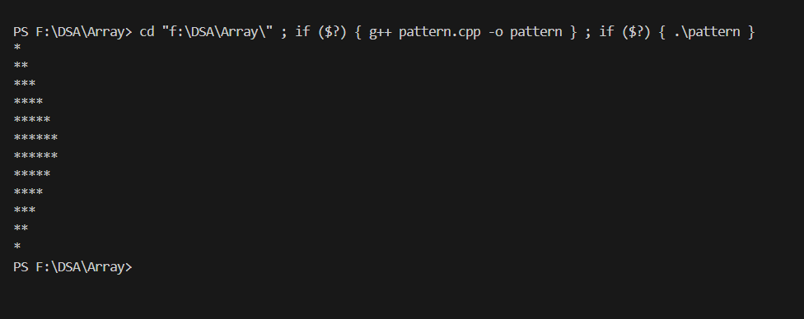

**Question No 03:**

Create a C++ program that simulates a student grading system. The program should allow the user to enter the marks of five subjects and calculate the average marks. Your program will repeatedly prompt the user for taking the marks for multiple students until they decide to exit.

#include <iostream>

using namespace std;

int main() {

    char choice;

    cout << "hello world";

    cout << "\nDo you want to enter marks for a student? (y/n): ";

    cin >> choice;

    for (; choice == 'y';) {

        float totalMarks = 0, marks;

        for (int i = 1; i <= 5; i++) {

            cout << "Enter marks for subject " << i << ": ";

            cin >> marks;

            totalMarks += marks;

        }

        float average = totalMarks / 5;

        cout << "Average Mark: " << average << endl;

        cout << "Do you want to enter marks for another student? (y/n): ";

        cin >> choice;

    };

    return 0;

}

**Output**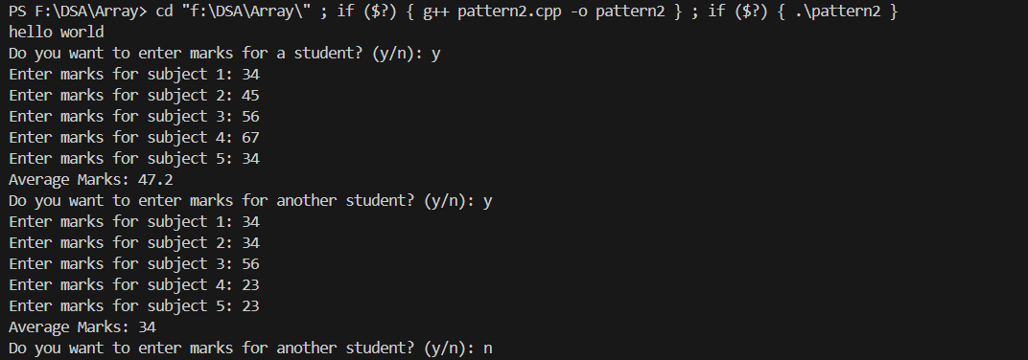

**-------------------The End--------------------------------**

Programming Fundamental /Lab Task 09

BY

Touqeer Ali (NUML-S25-18448)



SUBJECT (Programming Fundamental)

SUBMITTED TO (Mam Maryam Imtiaz Malik)

DATE:23-04-25

NATIONAL UNIVERSITY OF MODERN LANGUAGES ISLAMABAD

**Question NO 01:**

Write a function that print a triangle of stars.

using namespace std;

void PrintStars()

{

    for (int i = 0; i < 6; i++)

    {

        for (int j = 0; j < i; j++)

        {

            cout << "*";

        }

        cout << endl;

    }

}

int main()

{

PrintStars();

    return 0;

}

Output

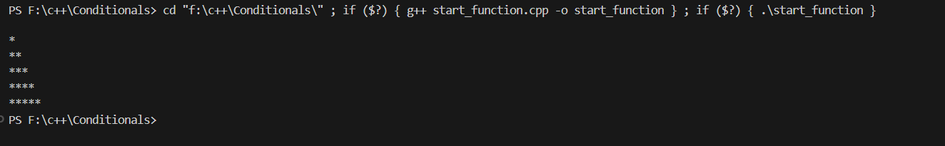

**Question No 02:**

Write a function that produces a table of the numbers from 1 to 10.

#include <iostream>

using namespace std;

void PrintTable()

{

    for (int i = 1; i < 11; i++)

    {

       cout<<5<<" * "<<i<<" = "<<5*i<<endl;

    }

}

int main()

{

PrintTable();

    return 0;

}

**Output**

p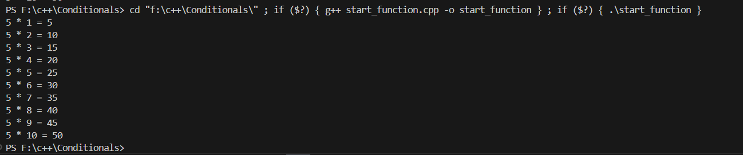

**Question No 03 :**

Write a C++ program that declares and defines a function to compute factorial of a number

#include <iostream>

using namespace std;

void CalculateFactorial(int n )

{

    int factorial = 1 ;

    for (int i = 1; i <=n; i++)

    {

        factorial *=i;

    }

    cout<<"The factorial of the "<<n <<" is "<<factorial;

}

int main()

{

    int n = 5 ;

    CalculateFactorial(n);

    return 0;

}

**Output**



**Question No 04**

Write a C++ program that declares and defines a function to check that entered number is a prime or not.

#include <iostream>

#include <cmath>

using namespace std;

void isPrime(int n)

{

    bool checkPrime = true;

    if (n < 2)

    {

        checkPrime = false;

    }

    for (int i = 2; i <= sqrt(n); i++)

    {

        if (n % i == 0)

        {

            checkPrime = false;

        }

    }

    if (checkPrime)

    {

        cout << n << " is the Prime number \n ";

    }

    else

    {

        cout << n << " is not  the Prime number \n ";

    }

}

int main()

{

    int n = 5;

    isPrime(n);

    return 0;

}

**Output**

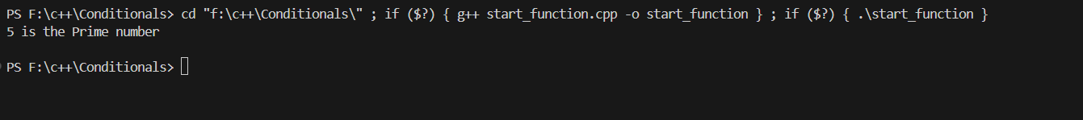

**------------------------------The End--------------------------------------**

Programming Fundamental TASK/Lab Task-10

BY

Touqeer Ali (NUML-S25-18448)



SUBJECT (Programming Fundamental)

SUBMITTED TO (Mam Maryam Imtiaz Malik)

DATE: 09-05-2025

NATIONAL UNIVERSITY OF MODERN LANGUAGES ISLAMABAD

**Question No 01:**

Write a C++ program that declares and defines a function to check that entered number is a prime or not.

#include <iostream>

#include <cmath>

bool isPrime(int);

using namespace std;

int main()

{

    int number;

    cout << "Enter the Number \n ";

    cin >> number;

    if (isPrime(number))

    {

        cout << number << " is the Prime number \n ";

    }

    else

    {

        cout << number << " is not  the Prime number \n ";

    }

    return 0;

}

bool isPrime(int n)

{

    bool CheckPrime = true;

    if (n < 2)

    {

        CheckPrime = false;

        return CheckPrime;

    }

    for (int i = 2; i <= sqrt(n); i++)

    {

        if (n % i == 0)

        {

            CheckPrime = false;

            break;

        }

    }

    return CheckPrime;

}

**Output**

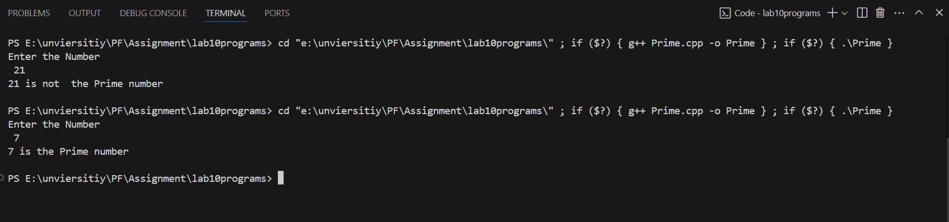

**Question No 02:**

Raising a number n to a power p is the same as multiplying n by itself p times. Write a function called power() that takes a double value for n and an int value for p, and passes the result as a double value to display() function. The function display() is used to print the result. Write a int main() function that gets values from the user to test these functions.

#include <iostream>

using namespace std;

double power(double n, int p)

{

    double result = 1;

    for (int i = 1; i <= p; i++)

    {

        result *= n;

    }

    return result;

}

void display(double result)

{

    cout << "Result is the " << result << endl;

}

int main()

{

    double n;

    int p;

    cout << "Enter the base \n ";

    cin >> n;

    cout << "Enter the Power \n ";

    cin >> p;

    double result = power(n, p);

    display(result);

    return 0;

}

**Solution:**

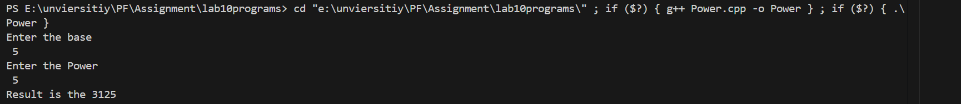

**Question No 03:**

Write a C++ program that defines a function isEven() which returns true if the number is even, and false otherwise. Use the function in main() to determine if a user-entered number is even or odd.

#include <iostream>

#include <vector>

using namespace std;

bool isEven(int n)

{

    if (n % 2 == 0)

    {

        return true;

    }

    return false;

}

int main()

{

    int number;

    cout << "Enter the number \n ";

    cin >> number;

    if (isEven(number))

    {

        cout << number << " is the Even number \n ";

    }

    else

    {

        cout << number << " is the Odd number \n ";

    }

    return 0;

}

**Solution**



**Question No 04:**

Write a function isArmstrong() that checks if a number is an Armstrong number (e.g., 153 is an Armstrong number because 13+53+33=1531^3 + 5^3 + 3^3 = 15313+53+33=153). Use it in main().

#include <iostream>

#include <cmath>

using namespace std;

bool isArmstrong(int n)

{

    int temp = n;

    int result = 0;

    while (n != 0)

    {

        int remainder = n % 10;

        result += pow(remainder, 3);

        n /= 10;

    }

    if (temp == result){

        return true;}

    return false;

}

int main()

{

    int number;

    cout<<"Enter the number \n ";

    cin>>number;

    if (isArmstrong(number))

    {

        cout << number << " is the Armstrong number \n ";

    }

    else

    {

        cout << number << " is  not the Armstrong number \n ";

    }

    return 0;

}

**Solution**

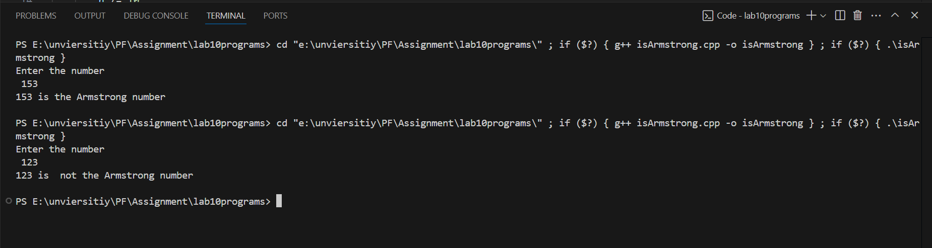

**--------------------------------The End-------------------------------------**

Programming Fundamental TASK/Lab Task 11

BY

Touqeer Ali (NUML-S25-18448)



SUBJECT (Programming Fundamental)

SUBMITTED TO (Mam Maryam Imtiaz Malik)

DATE:09-05-2025

NATIONAL UNIVERSITY OF MODERN LANGUAGES ISLAMABAD

**Question No 01:**

Write a C++ program that performs the following:

1. In the main function, prompt the user to enter a number.
2. Use a separate function to determine whether the number is prime. Pass the number as an argument to this function, which returns a boolean value indicating whether the number is prime.
3. If the number is prime, call another function to display an appropriate message.

#include <iostream>

#include <cmath>

bool isPrime(int);

using namespace std;

int main()

{

    int number;

    cout << "Enter the Number \n ";

    cin >> number;

    if (isPrime(number))

    {

        cout << number << " is the Prime number \n ";

    }

    else

    {

        cout << number << " is not  the Prime number \n ";

    }

    return 0;

}

bool isPrime(int n)

{

    bool CheckPrime = true;

    if (n < 2)

    {

        CheckPrime = false;

        return CheckPrime;

    }

    for (int i = 2; i <= sqrt(n); i++)

    {

        if (n % i == 0)

        {

            CheckPrime = false;

            break;

        }

    }

    return CheckPrime;

}

**Solution**



**Question No 02:**

Write a program to calculate the sum of unlimited numbers by using function overloading until users asks to stop summing.

• The first function “sum” has two parameters of integer type.

• The second function “sum” has two parameters of float type.

• Use loops to ask user whether the user wants to add further numbers call the sum function based on the type of input user has specified at the start of the program.

The output of the program should be like:

D-Double and I-Integer Enter Type of Input: I

Enter Input Number 1:12

…......

Number n:

SUM of Numbers:

#include <iostream>

using namespace std;

int sum(int a, int b) {

    return a + b;

}

float sum(float a, float b) {

    return a + b;

}

int main() {

    char type;

    cout << "D - Double and I - Integer" << endl;

    cout << "Enter Type of Input: ";

    cin >> type;

    char choice;

    if (type == 'I' || type == 'i') {

        int total = 0, num;

        int count = 1;

        do {

            cout << "Enter Input Number " << count << ": ";

            cin >> num;

            total = sum(total, num);

            count++;

            cout << "Do you want to add more numbers? (Y/N): ";

            cin >> choice;

        } while (choice == 'Y' || choice == 'y');

        cout << "SUM of Numbers: " << total << endl;

    }

    else if (type == 'D' || type == 'd') {

        float total = 0.0, num;

        int count = 1;

        do {

            cout << "Enter Input Number " << count << ": ";

            cin >> num;

            total = sum(total, num);

            count++;

            cout << "Do you want to add more numbers? (Y/N): ";

            cin >> choice;

        } while (choice == 'Y' || choice == 'y');

        cout << "SUM of Numbers: " << total << endl;

    }

    else {

        cout << "Invalid input type! Please enter 'I' or 'D'." << endl;

    }

    return 0;

}

**Output**

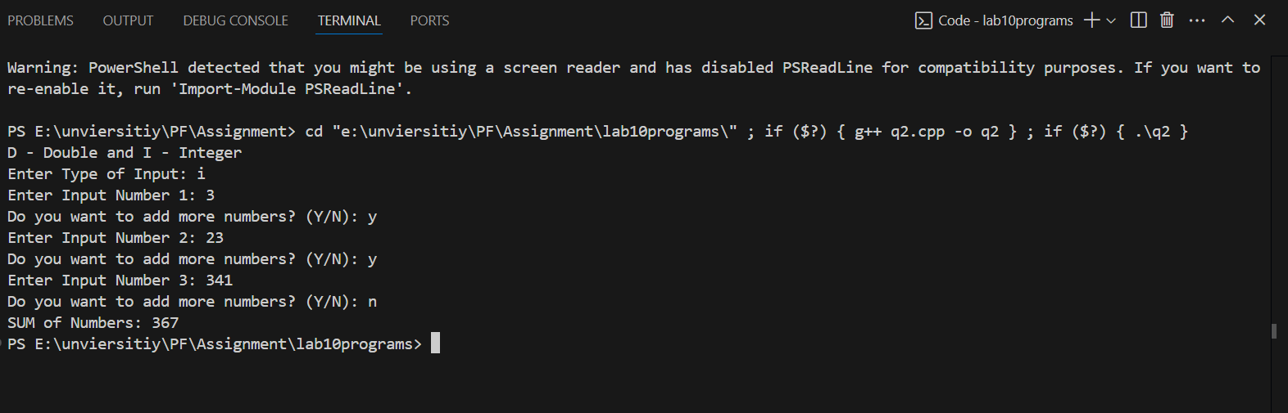

Programming Fundamental TASK/Lab Task 12

BY

Touqeer Ali (NUML-S25-18448)



SUBJECT (Programming Fundamental)

SUBMITTED TO (Mam Maryam Imtiaz Malik)

DATE:22-05-2025

NATIONAL UNIVERSITY OF MODERN LANGUAGES ISLAMABAD

**Question No 01:**

Write a program that initializes character array of length 7. The program then displays all values stored in an array.

#include <iostream>

using namespace std;

int main() {

    char charArray[7] = {'A', 'B', 'C', 'D', 'E', 'F', 'G'};

    cout << "Values in the character array:" << endl;

    for (int i = 0; i < 7; i++) {

        cout << " " << charArray[i] << endl;

    }

    return 0;

}

**Output**

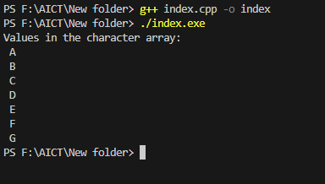

**Question No 02**

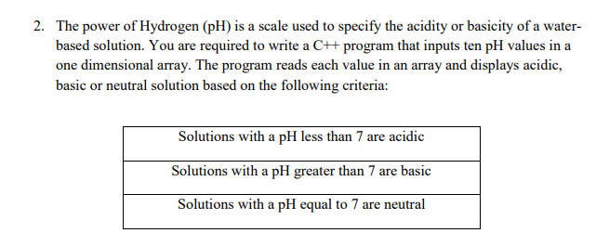

#include <iostream>

using namespace std;

int main() {

    int pH[10];

    cout << "Enter 10 pH values:\n";

    for (int i = 0; i < 10; i++) {

        cout << "pH value " << i + 1 << ": ";

        cin >> pH[i];

    }

    cout << "\nSolution types on  based on pH values:\n";

    for (int i = 0; i < 10; i++) {

        cout << "pH value " << pH[i] << " is ";

        if (pH[i] < 7) {

            cout << "Acidic\n";

        } else if (pH[i] > 7) {

            cout << "Basic\n";

        } else {

            cout << "Neutral\n";

        }

    }

    return 0;

}

**Output**

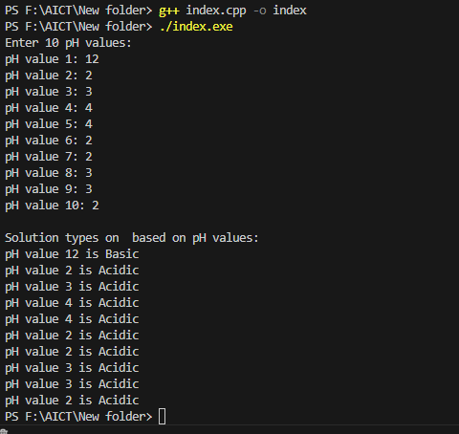

**Question No 03:**

Write a C++ program that declares a one dimensional array of size 10. It initializes the values of array. The program should update the values of arrays at index 3, 5, 7 and 9 using loops. The updated value should be 2.

#include <iostream>

using namespace std;

int main() {

    int arr[10] = {0, 1, 2, 3, 4, 5, 6, 7, 8, 9};

    for (int i = 3; i < 10; i+=2) {

            cout<<" "<<arr[i];

    }

    return 0;

}

**Output**

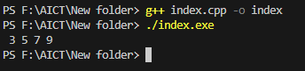

**Question No 04**

Matrix addition of two 3x3 matrix. Input the two matrices from the user and display before processing and after processing results.

#include <iostream>

using namespace std;

int main() {

    int matrix1[3][3], matrix2[3][3], result[3][3];

    cout << "Enter elements of first 3x3 matrix:\n";

    for (int i = 0; i < 3; i++) {

        for (int j = 0; j < 3; j++) {

            cin >> matrix1[i][j];

        }

    }

    cout << "Enter elements of second 3x3 matrix:\n";

    for (int i = 0; i < 3; i++) {

        for (int j = 0; j < 3; j++) {

            cin >> matrix2[i][j];

        }

    }

    cout << "\nFirst Matrix:\n";

    for (int i = 0; i < 3; i++) {

        for (int j = 0; j < 3; j++) {

            cout << matrix1[i][j] << " ";

        }

        cout << endl;

    }

    cout << "\nSecond Matrix:\n";

    for (int i = 0; i < 3; i++) {

        for (int j = 0; j < 3; j++) {

            cout << matrix2[i][j] << " ";

        }

        cout << endl;

    }

    for (int i = 0; i < 3; i++) {

        for (int j = 0; j < 3; j++) {

            result[i][j] = matrix1[i][j] + matrix2[i][j];

        }

    }

    cout << "\nResultant Matrix after Addition:\n";

    for (int i = 0; i < 3; i++) {

        for (int j = 0; j < 3; j++) {

            cout << result[i][j] << " ";

        }

        cout << endl;

    }

    return 0;

}

**Output :**

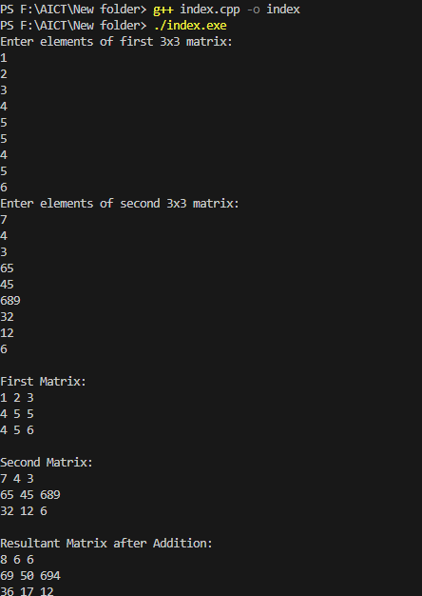

**Question No 05**

Implement a C++ program that initializes a one-dimensional array with character values. It then copies all vowels into one array and all consonants into another array.

// Implement a C++ program that initializes a one-dimensional array with character values.

// It then copies all vowels into one array and all consonants into another array.

#include<iostream>

using namespace std;

int main(){

char ch[10]={'a','e','q','p','i'};

char vowel[10];

char consonat[10];

int vowelcount = 0 ;

int consonantcount = 0 ;

for (int i = 0; i < 10; i++)

{

    if(ch[i]=='a' || ch[i]=='e' ||ch[i]=='i' ||ch[i]=='o' ||ch[i]=='u' ){

vowel[vowelcount]= ch[i];

vowelcount++;

    }else{

consonat[consonantcount] = ch[i];

consonantcount++;

    }

}

cout<<"The vowel are the \n ";

for (int i = 0; i < vowelcount; i++)

{

    cout<<" "<<vowel[i];

}

cout<<"\nThe consonant are the \n ";

for (int i = 0; i < consonantcount; i++)

{

    cout<<" "<<consonat[i];

}

    return 0 ;

}

**Output**

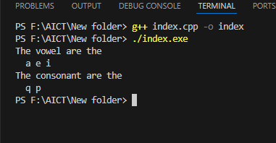

**Question 6**

Declare the following 4*4 two-dimensional array of type integer: 1 -2 3 3 2 4 -6 8 -3 5 -7 5 -1 4 8 -6 Display the negative values in the above two dim array

#include <iostream>

using namespace std;

int main() {

    int arr[4][4] = {

        {1, -2, 3, 3},

        {2, 4, -6, 8},

        {-3, 5, -7, 5},

        {-1, 4, 8, -6}

    };

    cout << "Negative values in the array are:\n";

    for (int i = 0; i < 4; i++) {

        for (int j = 0; j < 4; j++) {

            if (arr[i][j] < 0) {

                cout << arr[i][j] << " ";

            }

        }

    }

    return 0;

}

**Output**

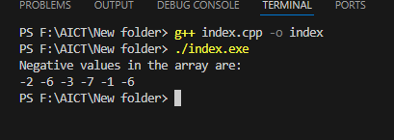

Programming Fundamental TASK/Lab Task 13

BY

Touqeer Ali (NUML-S25-18448)



SUBJECT (Programming Fundamental)

SUBMITTED TO (Mam Maryam Imtiaz Malik)

DATE:22-05-2025

NATIONAL UNIVERSITY OF MODERN LANGUAGES ISLAMABAD

**Question No 01:**

Create a structure called time. Its three members, all type int, should be called hours, minutes, and seconds. Write a program that prompts the user to enter a time value in hours, minutes, seconds. This can be in 12:59:59 format, or each number can be entered at a separate prompt (“Enter hours:”, and so forth). The program should then store the time in a variable of type struct time, and finally print out the total number of seconds represented by this time value:

long totalsecs = t1.hours*3600 + t1.minutes*60 + t1.seconds

#include <iostream>

using namespace std;

struct Time {

    int hours;

    int minutes;

    int seconds;

};

int main() {

    Time t1;

    cout << "Enter hours: ";

    cin >> t1.hours;

    cout << "Enter minutes: ";

    cin >> t1.minutes;

    cout << "Enter seconds: ";

    cin >> t1.seconds;

    long totalSeconds = t1.hours * 3600 + t1.minutes * 60 + t1.seconds;

    cout << "Total seconds: " << totalSeconds << endl;

    return 0;

}

**Output**

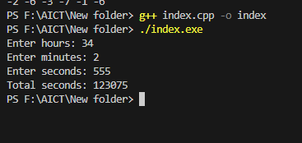

**Question No 02**

A phone number, such as (212) 767-8900, can be thought of as having three parts: the area code (212), the exchange (767), and the number (8900). Write a program that uses a structure to store these three parts of a phone number separately. Call the structure phone. Create two structure variables of type phone. Initialize one, and have the user input a number for the other one. Then display both numbers. The interchange might look like this: Enter your area code, exchange, and number: 415 555 1212 My number is (212) 767-8900 Your number is (415) 555-1212

#include <iostream>

using namespace std;

struct phone {

    int area;

    int exchange;

    int number;

};

int main() {

    phone myNumber = {212, 767, 8900};

    phone yourNumber;

    cout << "Enter your area code, exchange, and number: ";

    cin >> yourNumber.area >> yourNumber.exchange >> yourNumber.number;

    cout << "My number is (" << myNumber.area << ") " << myNumber.exchange << "-" << myNumber.number << endl;

    cout << "Your number is (" << yourNumber.area << ") " << yourNumber.exchange << "-" << yourNumber.number << endl;

    return 0;

}

**Solution**

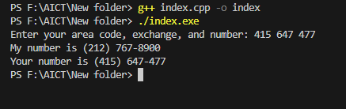

**Question No 03**

Write a C++ program that defines a structure to store the employee ID, name, salary, and department of an employee. The program should handle data for twenty employees, taking input values from the user

#include <iostream>

using namespace std;

struct Employee {

    int id;

    string name;

    float salary;

    string department;

};

int main() {

    Employee emp[20];

    for (int i = 0; i < 20; i++) {

        cout << "Enter data for employee " << i + 1 << ":\n";

        cout << "ID: ";

        cin >> emp[i].id;

        cout << "Name: ";

        cin >> emp[i].name;

        cout << "Salary: ";

        cin >> emp[i].salary;

        cout << "Department: ";

        cin >> emp[i].department;

        cout << endl;

    }

    cout << "Employee Informationn:\n";

    for (int i = 0; i < 20; i++) {

        cout << "ID: " << emp[i].id << ", Name: " << emp[i].name

             << ", Salary: " << emp[i].salary << ", Department: " << emp[i].department << endl;

    }

    return 0;

}